Winter Glow Juice Retreat
🌸 Pre-Christmas Juice Detox 🌸
14–17 November 2025
Dinard, Brittany, France

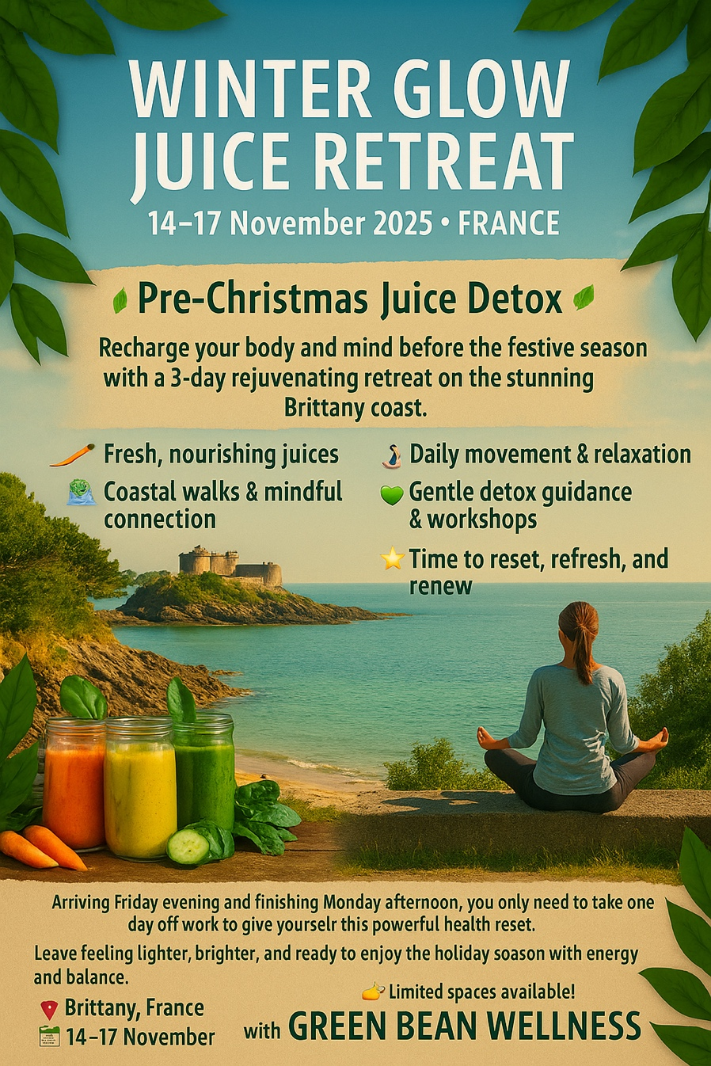
Location: Dinard, Brittany, France

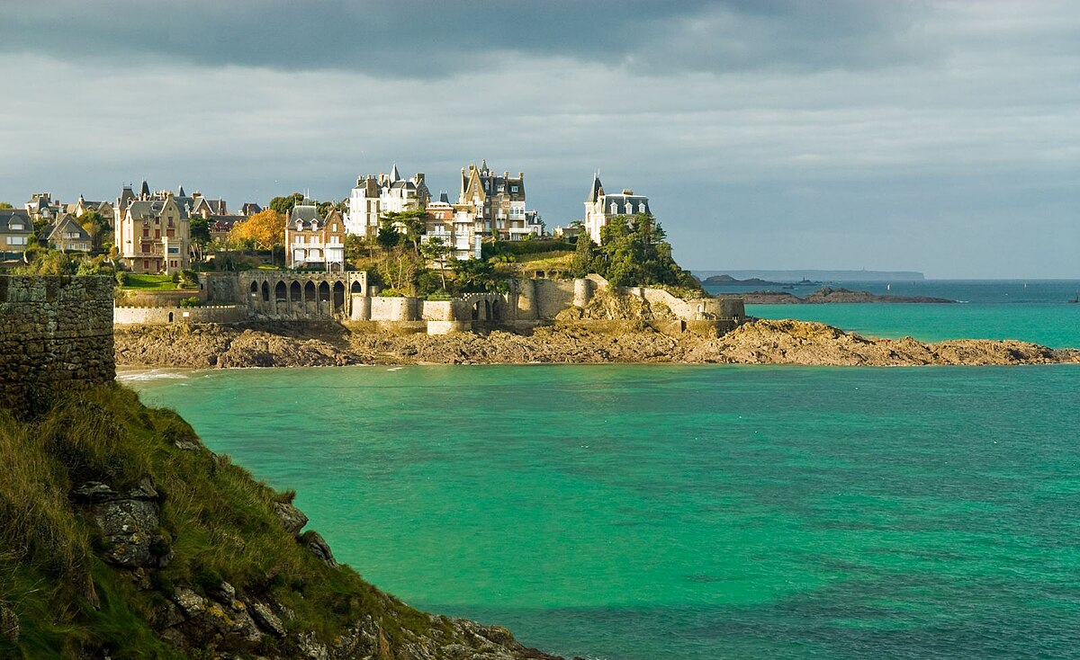
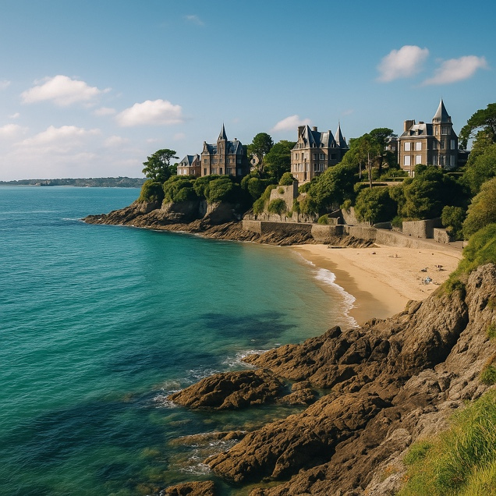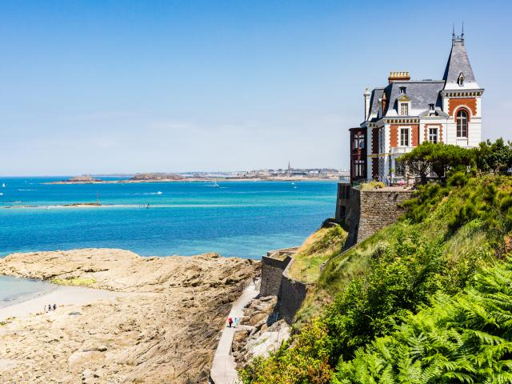
Retreat Schedule:
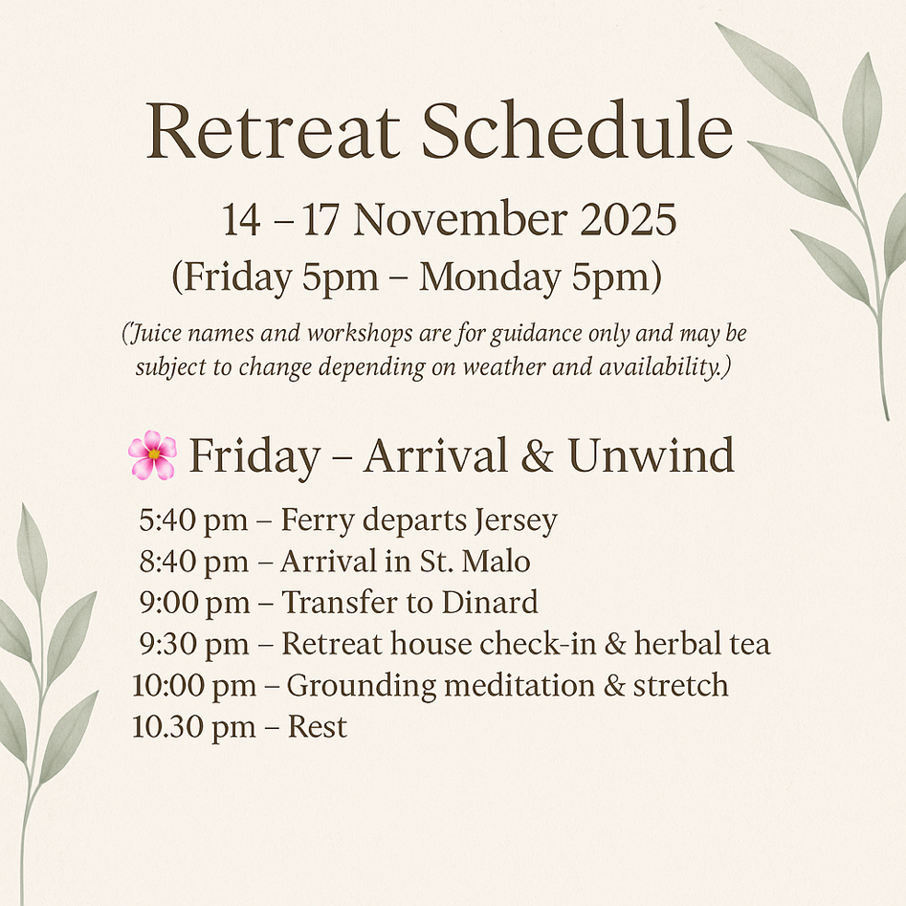
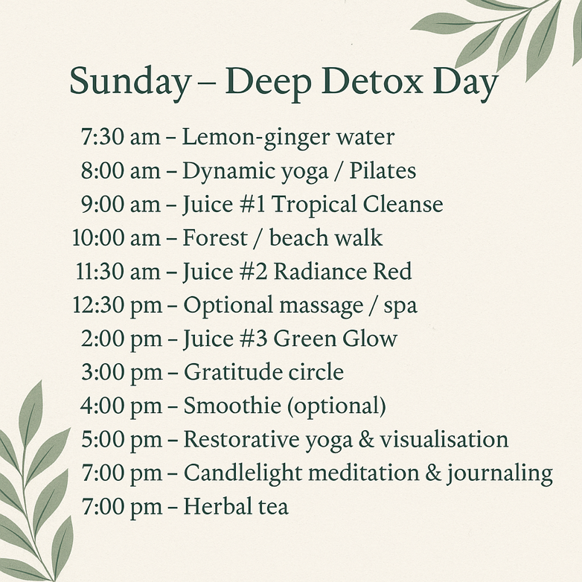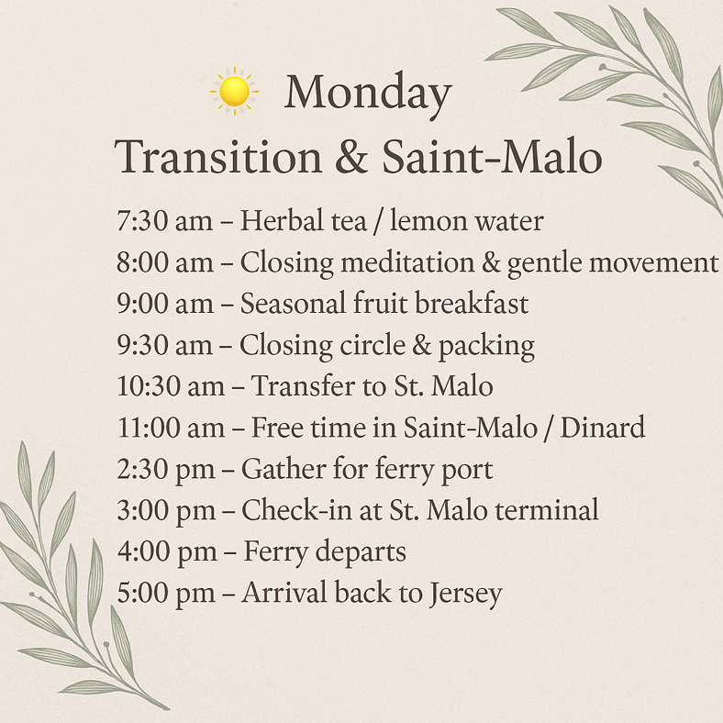

Accommodation:
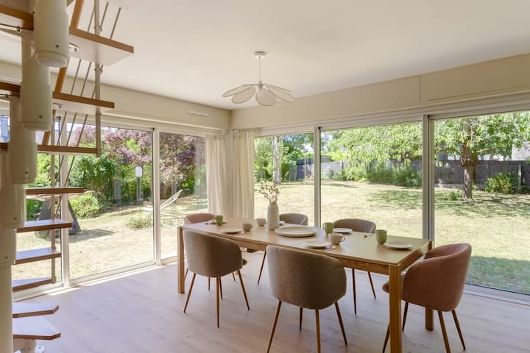

Payment:

You can pay with Debit Card via the link below,
if you want to use Credit Card, please let me know.

https://revolut.me/annapitt

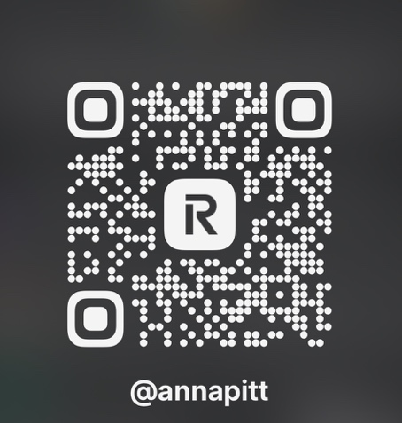

Payment & Cancellation Policy:
Payment
- As the retreat is less than 6 weeks away, full payment is required at the time of booking to confirm your place.

Cancellation by Participant
- £200 Deposits are non-refundable.
- If you cancel:
  - 30+ days before the retreat → 50% refund (excluding deposit).
  - 15–29 days before → 25% refund (excluding deposit).
  - 14 days or less → no refund.
- We strongly recommend that all participants take out personal travel insurance covering trip cancellation, health, and personal belongings.
Cancellation by Organiser
- In the unlikely event that we must cancel or postpone the retreat, you will receive a full refund of payments made.
- We are not responsible for costs outside of the retreat package (e.g. ferry, flights, trains, travel expenses).
Liability & Health
- Participants take part in all activities at their own risk and are responsible for their own health and wellbeing.
- By booking, you confirm that you are fit to participate in a juice & wellness retreat and will inform the organiser of any relevant medical conditions.
- You agree to help prepare your own juices, smoothies, and teas during the retreat, following safety and hygiene guidelines.

